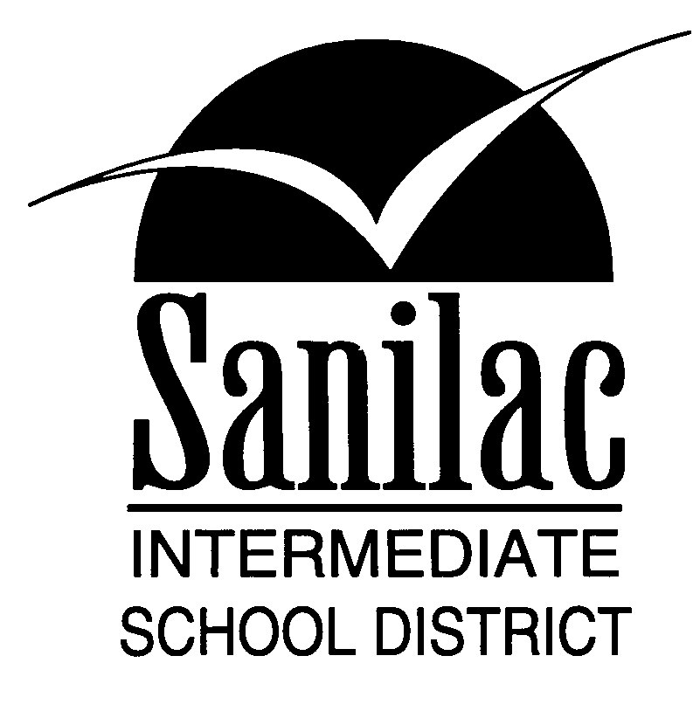
Special Education Services
46 North Jackson Street
Sandusky, Michigan 48471
810-648-2200

PERMISSION TO EXAMINE STUDENT FILES

____________________________________, has permission
to examine the school files of: ___________________________,
for the following reason: _____________________________.
It is understood that any and all information contained in these files are confidential and cannot be shared with any other entity.

This permission is in effect until: _____________________.

____________________________________ ____________
Parent/Guardian/Other Signature Date

